LONDON YOUTH STRING ORCHESTRA
LYSO is an ensemble for London's most talented string players and applicants should be above diploma standard to audition aged up to 25 years old. LYSO work at a high level exploring a variety of String Orchestra repertoire, including as many solo opportunities for our players as possible. Tutors in previous courses included principals of the Royal Ballet Sinfonia and LSO. This course will be conducted by Simon Chalk.
Two contrasting pieces to be prepared for audition. There is no need to re-audition if you are already a member of the orchestra.
LONDON CHILDREN’S STRING ORCHESTRA
LCSO is made up of three orchestras. Main Children’sOrchestra
is for string players of grades 7 to post-diploma standard, aged 8 to 16. No audition is required. Conducted by Sebastian See Scheirenberg. LCSO – Training Orchestra
is for young string players grades 3 to 7, aged 7 to 13. No audition is required. This group is led by Simon Chalk and Sarah Drury. Beginner Strings
is our program for children who are grade 2 or below for their first exploration of playing in an
Ensemble. No audition required.

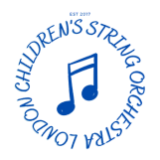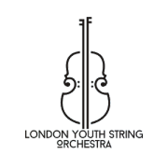
21 - 22 February 2026 at United Reformed Church Palmers Green N13 on 21st and St John’s Church Friern Barnet N11 on 22nd.
Saturday 21st:
LYSO 4:30-7:15
LCSO 10:30 - 5:30
Training Orchestra 2:00 - 4.30
Beginners 12:30 - 1:45
Sunday 22nd:
LYSO 11:45 - Concert 5:40
LCSO 11:30 - Concert 6:10
Training Orchestra 2:45 - Concert 5:25
Beginners 4:00 - Concert 5:15
Fees
LYSO £115* (siblings discount £110) *only £20 for full-time Conservatoire students
LCSO £128 (siblings £115)
Training £88 (siblings £78)
Beginners £48 (siblings £40)
Deposit of £50 required by 2nd February and the full fee by 15th February.
APPLICATIONS NOW OPEN
Sign up at www.londonyouthstringorchestras.org

